GS System Design Interview Questions

Candidate Instructions:
- Create a Java Maven project in IntelliJ.
- Code each Problem Statement in its own package.
- Each class should have a main method to run the scenario.
- Upload your project to your SharePoint folder
- Create a sub-folder “6.GS_System_Design_Questions” in folder “Labs” as below:
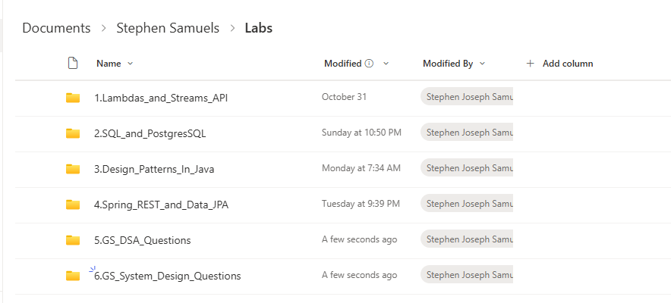
- Only upload the src folder and pom.xml
- Do not zip and upload the project.
- Test that your uploaded project can be downloaded, imported into IntelliJ and run.
- Upload your Class and Sequence diagrams for each Problem Statement. Ensure a proper naming convention.
=================================================================

Versioned Stack
Problem Statement: Design a stack that supports versioning. Each push or pop creates a new version. Implement printVersion(version) to retrieve stack contents at that version.
Hint: Use a list of stacks or maintain a history map keyed by version. Consider immutability for old versions and efficient copy-on-write for new versions.

Rate Limiting (Fixed Window)
Problem Statement: Implement a fixed window rate limiter using HashMap and custom class to track request count and timestamps.
Hint: Use HashMap<key, Counter> with timestamp buckets. Reset counters at window boundaries using ScheduledExecutorService or time checks.

Interview Scheduling System
Problem Statement: Design a system using LinkedLists and HashMaps to manage interviewers, candidates, and interview rounds.
Hint: Maintain HashMap<interviewerId, LinkedList<slots>> and HashMap<candidateId, LinkedList<slots>>. Use Streams to find common free slots.

Delivery Overlap Detection
Problem Statement: Use HashMap to store delivery intervals and Java Streams to find overlapping deliveries with a given interval.
Hint: Store intervals in HashMap<deliveryId, Interval>. Use Streams to filter intervals where start < givenEnd && end > givenStart.

HashMap Implementation
Problem Statement: Explain how to implement a HashMap, handle collisions, and choose a good hash function.
Hint: Use array of buckets with LinkedList or Tree for collisions. Compute index as hash(key) % capacity. Resize on load factor threshold.

Fibonacci Series Calculator with Performance Constraints
Problem Statement:
Design and implement a Fibonacci number generator that supports computing the Nth Fibonacci number efficiently under strict performance constraints. The solution should handle large N without stack overflow, minimize time complexity, and avoid redundant computations.
Constraints:
Must support N up to 10^6 without excessive memory or time overhead.
- Compare iterative vs recursive approaches and justify your choice.
- If using recursion, apply memoization to reduce complexity from exponential to linear.
- Optimize for O(n) time and O(1) space where possible.
- Provide a method getFibonacci(n) that returns the Nth Fibonacci number.
- Include unit tests for edge cases (e.g., n=0, n=1, large n).
Hint:
Recursive approach has exponential complexity; use memoization with HashMap or iterative DP for O(n) time and O(1) space.

Transaction Idempotency Registry (Payments/Transfers)
Problem Statement: Design a lightweight Idempotency Registry that prevents duplicate execution of payment requests (e.g., same merchantId + clientId + idempotencyKey). The service should support create/check/finalize flows and TTL cleanup for stale keys.
Hint: Use ConcurrentHashMap for thread safety, idempotency key as composite key, ScheduledExecutor for TTL cleanup. Persist critical keys for recovery.

FX Rate Cache with TTL & Source Fallback (Treasury/Quotes)
Problem Statement: Build an FX rate cache for currency pairs like USD/INR, EUR/USD. Primary source: provider A; fallback: provider B. Support TTL per pair, forced refresh, and streaming updates to listeners.
Hint: Maintain HashMap<Pair,Quote> with timestamp and ttlMillis. Scheduled refresh tasks, fallback source logic, and listener subscriptions for updates.

Ledger Reconciliation Mini-Engine (PSP vs Internal Ledger)
Problem Statement: Design a reconciliation routine that takes PSP statement rows and internal ledger entries and finds matches and breaks. Support strict ID match, then amount + time window match, then mark exceptions.
Hint: Index PSP rows by extId in HashMap. First strict match, then Streams for fuzzy match on amount/time. Output matched and breaks lists.
PSP - Payment Service Provider (like Stripe, PayPal, Razorpay, etc.).

Velocity & Device Risk Rules (Fraud Pre-Check)
Problem Statement: Implement a velocity rules pre-check that blocks suspicious transactions based on counts per account/device in sliding windows (e.g., N tx in 5 minutes, M declines in 1 minute, amount spikes per device).
Hint: Use HashMap<Key,Deque<Event>> for sliding window checks. Evict old events, compute counts via Streams, apply thresholds for ALLOW/REVIEW/BLOCK.
UML Diagram Requirements:
Each Problem Statement must be accompanied by Class and Sequence Diagram(s).
Class Diagram Tips:
- Identify main classes and their responsibilities.
- Show attributes and key methods for each class.
- Depict relationships: association, aggregation, composition.

Sequence Diagram Tips:
- Start with actors and main system components.
- Show method calls and responses in chronological order.
- Include loops/conditions for iterative or conditional flows.

***************************************************************************************

